DS-PD2-T10AME-EH
Outdoor Dual-Tech Detector
The DS-PD2-T10AME-EH is a high security outdoor detector, combining established and patented technologies such as Tri-Digital Detection Signal Processing and Tri-Anti-Mask Technology which have been adapted to enhance performance in extreme outdoor conditions. | 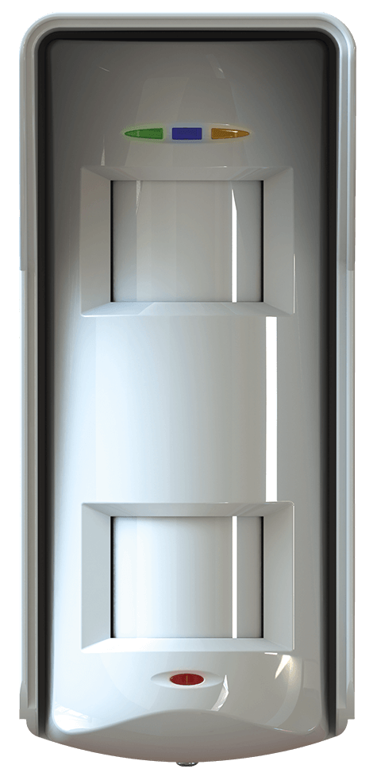
AVAILABLE MODEL

DS-PD2-T10AME-EH | Outdoor Dual-Tech Detector
DS-PDB-EX-Wall bracket | Wall bracket (Need to order separately )
DS-PDB-EX-Adapter | Extend coverage to 90 degrees (Need to order separately, using together with DS-PDB-EX-Wall bracket)
DS-PDB-EX-Fixed bracket | Add two detectors back to back to create 20m perimeter protection (Need to order separately)

*All bracket need to order separately.

MAIN FEATURES

- Microwave + two PIR sensors
- Weather Proof sealed optics
- Heavy duty ultraviolet filter
- 10m volumetric coverage
- Tri-Anti-Masking Technology
- Digital Temperature Compensation

SPECIFICATION

Outdoor Dual-Tech Detector
Detection Range | 10m, detection angle: 90°
Detection Speed | 0.25m/s ~ 2.5m/s
Animal Immunity | 10kg
Power Supply | 9-16V DC 13.8V DC typical
Operation Temperature | -25℃ ~ +60℃
Dimension(H*W*D) | 188mm*84mm*77mm
Weight | 300g
Installation Environment | Outdoor
Installation Height | 1.8-2.4m

